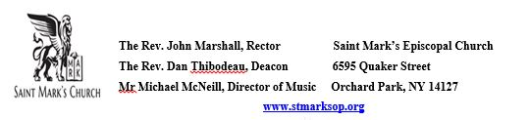

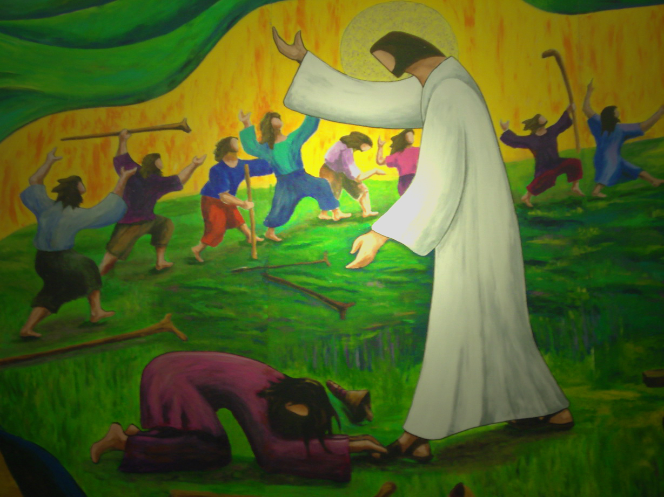

Celebrant: The Rev’d John Marshall
Intercessor and Eucharistic Minister: Dee Jakel
Eucharistic Minister: Mary Marshall
Lectors: Alan Dewart and Mary Marshall
Pentecost 18
October 12, 2025
Holy Eucharist Rite II
Prelude
"Deep River" (trad., arr. Adolphus Hailstork)
Stand and sing Hymn 390 "Praise to the Lord, the Almighty, the King of creation"

Blessed be God: Father, Son, and Holy Spirit
And blessed be his kingdom, now and for ever. Amen.

There is one Body and one Spirit;
There is one hope in God’s call to us;
One Lord, one Faith, one Baptism;
One God and Father of all.

Opening Song of Praise S 280 Glory to God (Canticle 20) (Powell)

Celebrant | The Lord be with you.
People | And also with you.
Celebrant | Let us pray.
Lord, we pray that your grace may always precede and follow us, that we may continually be given to good works; through Jesus Christ our Lord, who lives and reigns with you and the Holy Spirit, one God, now and for ever. Amen.
The Lessons

A Reading from the Second book of Kings.

2 Kings 5:1-3, 7-15c
Naaman, commander of the army of the king of Aram, was a great man and in high favor with his master, because by him the Lord had given victory to Aram. The man, though a mighty warrior, suffered from leprosy. Now the Arameans on one of their raids had taken a young girl captive from the land of Israel, and she served Naaman's wife. She said to her mistress, "If only my lord were with the prophet who is in Samaria! He would cure him of his leprosy."
When the king of Israel read the letter, he tore his clothes and said, "Am I God, to give death or life, that this man sends word to me to cure a man of his leprosy? Just look and see how he is trying to pick a quarrel with me."
But when Elisha the man of God heard that the king of Israel had torn his clothes, he sent a message to the king, "Why have you torn your clothes? Let him come to me, that he may learn that there is a prophet in Israel." So Naaman came with his horses and chariots, and halted at the entrance of Elisha's house. Elisha sent a messenger to him, saying, "Go, wash in the Jordan seven times, and your flesh shall be restored and you shall be clean." But Naaman became angry and went away, saying, "I thought that for me he would surely come out, and stand and call on the name of the Lord his God, and would wave his hand over the spot, and cure the leprosy! Are not Abana and Pharpar, the rivers of Damascus, better than all the waters of Israel? Could I not wash in them, and be clean?" He turned and went away in a rage. But his servants approached and said to him, "Father, if the prophet had commanded you to do something difficult, would you not have done it? How much more, when all he said to you was, `Wash, and be clean'?" So he went down and immersed himself seven times in the Jordan, according to the word of the man of God; his flesh was restored like the flesh of a young boy, and he was clean.
Then he returned to the man of God, he and all his company; he came and stood before him and said, "Now I know that there is no God in all the earth except in Israel."
The Word of the Lord.
Thanks be to God.
PSALM 111
The choir will chant this morning's psalm. The congregation is invited to join the chant on the verses in bold type, and to join in the antiphon.
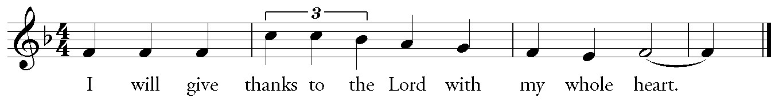
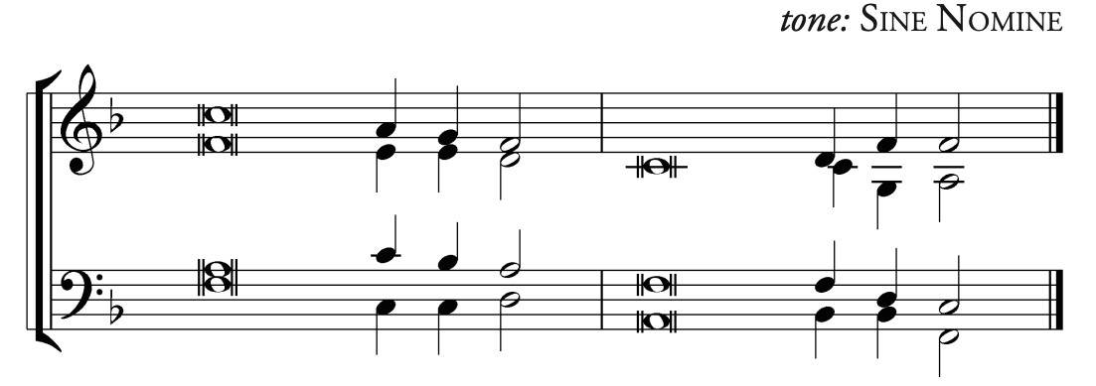
1 Hallelujah! … I will give thanks to the Lord with my [whole] heart,*
in the assembly of the upright, … in the [con]-gregation.
2 Great are the [deeds of] the Lord!*
They are studied by [all who] delight in them.
3 His work is full of [majesty] and splendor,*
and his righteousness en-[dures] forever.
4 He makes his marvelous works to [be] remembered;*
the Lord is gracious and [full of] compassion.
Antiphon
5 He gives food to [those] who fear him;*
he is ever mindful [of] his covenant.
6 He has shown his people the power [of] his works*
in giving them the [lands of] the nations.
7 The works of his hands are [faithfulness] and justice;*
all his com-[mandments] are sure.
8 They stand fast for-[ever] and ever,*
because they are done in [truth] and equity.
Antiphon
9 He sent redemption to his people; … he commanded his [covenant] forever;*
holy and awesome [is] his name.
10 The fear of the Lord is the be-[ginning] of wisdom;*
those who act accordingly have a good understanding. …
His praise en-[dures] forever.
Antiphon
A Reading from Paul's Second letter to Timothy.

2 Timothy 2:8-15
Remember Jesus Christ, raised from the dead, a descendant of David-- that is my gospel, for which I suffer hardship, even to the point of being chained like a criminal. But the word of God is not chained. Therefore I endure everything for the sake of the elect, so that they may also obtain the salvation that is in Christ Jesus, with eternal glory. The saying is sure:
If we have died with him, we will also live with him;
if we endure, we will also reign with him;
if we deny him, he will also deny us;
if we are faithless, he remains faithful--
for he cannot deny himself.
Remind them of this, and warn them before God that they are to avoid wrangling over words, which does no good but only ruins those who are listening. Do your best to present yourself to God as one approved by him, a worker who has no need to be ashamed, rightly explaining the word of truth.
The Word of the Lord.
Thanks be to God.
Stand and sing Hymn WL&P (green hymnal) 776 "No saint on earth lives life to self alone"

The Holy Gospel according to Luke
Glory to you, Lord Christ.

Luke 17:11-19
On the way to Jerusalem Jesus was going through the region between Samaria and Galilee. As he entered a village, ten lepers approached him. Keeping their distance, they called out, saying, "Jesus, Master, have mercy on us!" When he saw them, he said to them, "Go and show yourselves to the priests." And as they went, they were made clean. Then one of them, when he saw that he was healed, turned back, praising God with a loud voice. He prostrated himself at Jesus' feet and thanked him. And he was a Samaritan. Then Jesus asked, "Were not ten made clean? But the other nine, where are they? Was none of them found to return and give praise to God except this foreigner?" Then he said to him, "Get up and go on your way; your faith has made you well."
The Gospel of the Lord.
Praise to you, Lord Christ.
Gospel Alleluia
Celtic Alleluia (O'Carroll/Walker)
Alleluia, Alleluia!
Alleluia, Alleluia!
Sit for The Homily The Rev’d John Marshall
The Candidate for Holy Baptism will now be presented.

Parents and Godparents: I present Colton Lee Rupp to receive the Sacrament of Baptism.

Will you be responsible for seeing that the child you present is brought up in the Christian faith and life?

Parents and Godparents: I will, with God’s help.

Will you by your prayers and witness help this child to grow into the full stature of Christ?

Parents and Godparents: I will, with God’s help.

Do you renounce Satan and all the spiritual forces of wickedness that rebel against God?

Parents and Godparents: I renounce them.

Do you renounce the evil powers of this world which corrupt and destroy the creatures of God?

Parents and Godparents: I renounce them.

Do you renounce all sinful desires that draw you from the love of God?

Parents and Godparents: I renounce them.

Do you turn to Jesus Christ and accept him as your Savior?

Parents and Godparents: I do.

Do you put your whole trust in his grace and love?

Parents and Godparents: I do.

Do you promise to follow and obey him as your Lord?

Parents and Godparents: I do.

Will you who witness these vows do all in your power to support this person in their life in Christ?

All: We will.

Let us join with him who is committing himself to Christ and renew our own baptismal covenant.

The Baptismal Covenant

Do you believe in God the Father?
I believe in God, the Father almighty, creator of heaven and earth.
Do you believe in Jesus Christ, the Son of God?
I believe in Jesus Christ, his only Son, our Lord.
He was conceived by the power of the Holy Spirit and born of the Virgin Mary.
He suffered under Pontius Pilate, was crucified, died, and was buried.
He descended to the dead.
On the third day he rose again.
He ascended into heaven, and is seated at the right hand of the Father.
He will come again to judge the living and the dead.

Do you believe in God the Holy Spirit?
I believe in the Holy Spirit,
The holy catholic Church,
The communion of saints,
The forgiveness of sins,
The resurrection of the body,
And the life evertlasting.

Will you continue in the apostles’ teaching and fellowship in the breaking of bread, and in the prayers?
I will, with God’s help.

Will you persevere in resisting evil, and, whenever you fall into sin, repent and return to the Lord?
I will, with God’s help.

Will you proclaim by word and example the Good News of God in Christ?
I will, with God’s help.

Will you seek and serve Christ in all persons, loving your neighbor as yourself?
I will, with God’s help.

Will you strive for justice and peace among all people, and respect the dignity of every human being?
I will, with God’s help.
Prayers for the Candidate

Let us now pray for Colton who is to receive the Sacrament of new birth.

Deliver him, O Lord, from the way of sin and death.
Lord, hear our prayer.
Open his heart to your grace and truth.
Lord, hear our prayer.

Fill him with your holy and life-giving Spirit.
Lord, hear our prayer.

Keep him in the faith and communion of your holy Church.
Lord, hear our prayer.

Teach him to love others in the power of the Spirit.
Lord, hear our prayer.

Send him into the world in witness to your love.
Lord, hear our prayer.

Bring him to the fullness of your peace and glory.
Lord, hear our prayer.

Grant, O Lord, that all who are baptized into the death of Jesus Christ your Son may live in the power of his resurrection and look for him to come again in glory; who lives and reigns now and forever. Amen

Thanksgiving over the Water

The Lord be with you.
And also with you.

Let us give thanks to the Lord our God.
It is right to give him thanks and praise.
We thank you, Almighty God, for the gift of water. Over it the Holy Spirit moved in the beginning of creation.
Through it you led the children of Israel out of bondage in Egypt into the land of promise. In it your Son Jesus received the baptism of John and was anointed by the Holy Spirit as the Messiah, the Christ, to lead us, through his death and resurrection, from the bondage of sin into everlasting life.

We thank you, Father, for the water of Baptism. In it we are buried with Christ in his death. By it we share in his resurrection. Through it we are reborn by the Holy Spirit.

Therefore in joyful obedience to your Son, we bring his fellowship to those who come to him in faith, baptizing them in the Name of the Father, and of the Son, and of the Holy Spirit.
Now sanctify this water, we pray you, by the power of your Holy Spirit, that those who here are cleansed from sin and born again may continue for ever in the risen life of Jesus Christ our Savior.

To him, to you, and to the Holy Spirit, be all honor and glory, now and for ever. Amen.

The Baptism

Colton, I baptize you in the Name of the Father, and of the Son, and of the Holy Spirit. Amen.

Let us pray.

Heavenly Father, we thank you that by water and the Holy Spirit you have bestowed upon this your servant the forgiveness of sin, and have raised him to the new life of grace. Sustain him, O Lord, in your Holy Spirit. Give him an inquiring and discerning heart, the courage to will and to persevere, a spirit to know and to love you, and the gift of joy and wonder in all your works. Amen.

Colton, you are sealed by the Holy Spirit in Baptism and marked as Christ’s own for ever. Amen

Presenting the Light of Christ

Let us welcome the newly baptized.

Together
We receive you into the household of God.
Confess the faith of Christ crucified, proclaim his resurrection, and share with us in his eternal priesthood.

You have put on Christ,
in him you have been baptized.
Alleluia, alleluia.

Celebrant The peace of the Lord be always with you.
People And also with you.

OFFERTORY ANTHEM
"Your Hands, O Lord, In Days of Old" (text: Edward H. Plumptre; music: Carson Cooman)
DOXOLOGY Hymn 380, v. 3
Praise God, from whom all blessings flow;
praise him, all creatures here below;
praise him above, ye heavenly host:
praise Father, Son, and Holy Ghost.

The Holy Communion

Celebrant | The Lord be with you.
People | And also with you.
Celebrant | Lift up your hearts.
People | We lift them to the Lord.
Celebrant | Let us give thanks to the Lord our God.
People | It is right to give him thanks and praise.
We praise you and we bless you, holy and gracious God, source of life abundant. From before time you made ready the creation.
Your Spirit moved over the deep and brought all things into being: sun, moon, and stars; earth, winds, and waters; and every living thing.

You made us in your image, and taught us to walk in your ways. But we rebelled against you, and wandered far away; and yet, as a mother cares for her children, you would not forget us.
Time and again you called us to live in the fullness of your love.

And so this day we join with Saints and Angels in the chorus of praise that rings through eternity, lifting our voices to magnify you as we sing:

Sanctus WLP 858 (green hymnal) Holy, holy, holy (American folk melody, harm. Pruner)
Holy, holy, holy Lord, God of power and might,
heaven and earth are full of your glory.
Hosanna in the highest.
Blessed is the one who comes in the name of the Lord.
Hosanna in the highest.

Glory and honor and praise to you, holy and living God. To deliver us from the power of sin and death and to reveal the riches of your grace, you looked with favor upon Mary, your willing servant, that she might conceive and bear a son, Jesus the holy child of God.

Living among us, Jesus loved us. He broke bread with outcasts and sinners, healed the sick, and proclaimed good news to the poor. He yearned to draw all the world to himself yet we were heedless of his call to walk in love.

Then, the time came for him to complete upon the cross the sacrifice of his life, and to be glorified by you.

On the night before he died for us, Jesus was at table with his friends. He took bread, gave thanks to you, broke it, and gave it to them, and said: “Take, eat: This is my Body, which is given for you. Do this for the remembrance of me.”
As supper was ending, Jesus took the cup of wine. Again, he gave thanks to you, gave it to them, and said: “Drink this, all of you: This is my Blood of the new Covenant, which is poured out for you and for all for the forgiveness of sins. Whenever you drink it, do this for the remembrance of me.”
Now gathered at your table, O God of all creation, and remembering Christ, crucified and risen, who was and is and is to come, we offer to you our gifts of bread and wine, and ourselves, a living sacrifice.

Pour out your Spirit upon these gifts that they may be the Body and Blood of Christ. Breathe your Spirit over the whole earth and make us your new creation, the Body of Christ given for the world you have made.

In the fullness of time bring us, with all your saints, from every tribe and language and people and nation, to feast at the banquet prepared from the foundation of the world.

Through Christ and with Christ and in Christ, in the unity of the Holy Spirit, to you be honor, glory, and praise, for ever and ever. AMEN

And now, as our Savior Christ has taught us, we are bold to say,

Our Father, who art in heaven,
hallowed be thy Name,
thy kingdom come,
thy will be done, on earth as it is in heaven.
Give us this day our daily bread.
And forgive us our trespasses,
as we forgive those who trespass against us.
And lead us not into temptation,
but deliver us from evil.
For thine is the kingdom,
and the power, and the glory,
forever and ever. Amen.

Fraction Anthem LEVAS 269 Lamb of God
(from Eucharist of the Soul by Lena McLin)
Lamb of God, you take away the sins of the world:
have mercy on us.
Lamb of God, you take away the sins of the world:
have mercy on us.
Lamb of God, you take away the sins of the world:
grant us peace.

Communion Hymn
"Healing River of the Spirit"
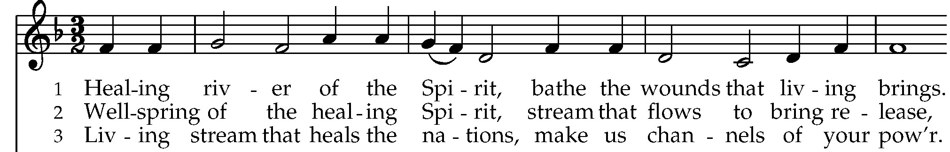
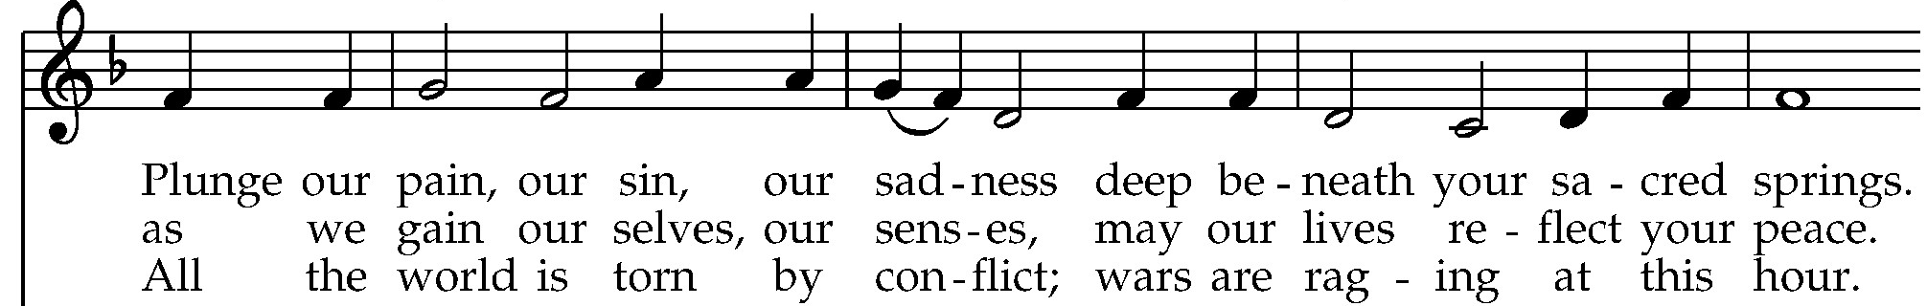
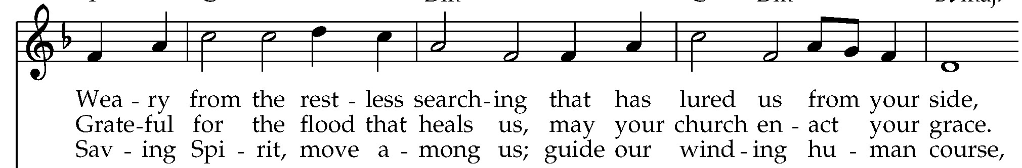
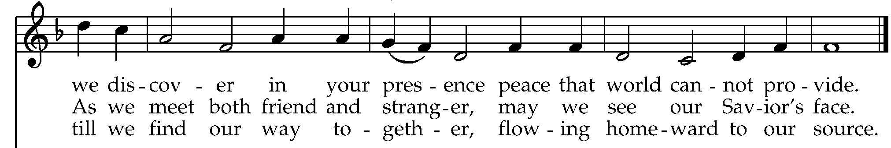
The Prayer after Communion
Let us pray.
Loving God,
we give you thanks
for restoring us in your image
and nourishing us with spiritual food
in the Sacrament of Christ’s Body and Blood.
Now send us forth
a people, forgiven, healed, renewed;
that we may proclaim your love to the world
and continue in the risen life of Christ our Savior. Amen.

Blessing
The blessing of God Almighty, the Father, the Son, and the Holy Spirit, be upon you and remain with you for ever. Amen.
Post-Communion Hymn
Stand and sing Hymn 410 "Praise, my soul, the King of heaven"

 | Let us go forth in the name of Christ.
People | Thanks be to God.

Postlude
"Deep River" (trad., arr. David Hurd)

JOIN US FOR OUR NEXT CONCERT
SUNDAY, OCTOBER 19, 3PM
KINDRED is the husband and wife team of David and Felicia Meyer. Schooled in theatre and classical music as well as folk and popular song, they bring a compelling stage presence to their wide ranging repertoire capturing the hearts of audiences throughout the United States and Canada. With Felicia Meyer's incredible voice and guitar, and Dave Meyer's dynamic and versatile cello playing, KINDRED brings to life both old and new music in the Celtic tradition. More information at 4kindred.com.

JOIN US FOR AN EVENSONG FOR THE FEAST OF ST. JAMES!
Thursday, October 23, at 7pm, join us for an Evensong Service to celebrate the Feast of St. James. This contemplative service will feature music from the St. Mark's Choir. A simple dessert reception will follow in the Morrow Room.



St. Mark's Prayer Roll

We pray for:
Anglican Communion – The Church of the Province of Uganda
In the Diocese – Advent, Kenmore & Trinity, Lancaster

Those in need or trouble – Heidi, Joanne, Paul, Mike, Colleen, Robin, Cathy, Bethany, Heather, Jim, Rosie, Anthony, Baby Theodore, Steve, Jeanette, Margaret, Thomas, Gabriel, Karen, Natalie, Darlene, Larry, Tony, Baby Sofia, Cheryl, Paula, Sheila, Sue, Joe, Mike, Sarah, Jeff

The flowers on the altar are given by Ellen DeVincentis in memory of Jack Cwynar

This Week at St. Mark’s
Sunday 10/12
8:00am Eucharist Rite I
9:45am Sunday School K – Grade 5
10:00am Eucharist Rite II
11:00am Coffee Hour
Tuesday 10/14
7:00pm Vestry Meeting
Wednesday 10/15
10:00am Eucharist Rite I
11:00am Book Club
12:00pm Men’s Club
Saturday 10/18
6:00pm Open AA Meeting
Sunday 10/19
8:00am Eucharist Rite I
9:45am Sunday School K – Grade 5
10:00am Eucharist Rite II
11:00am Coffee Hour

