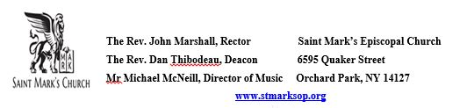

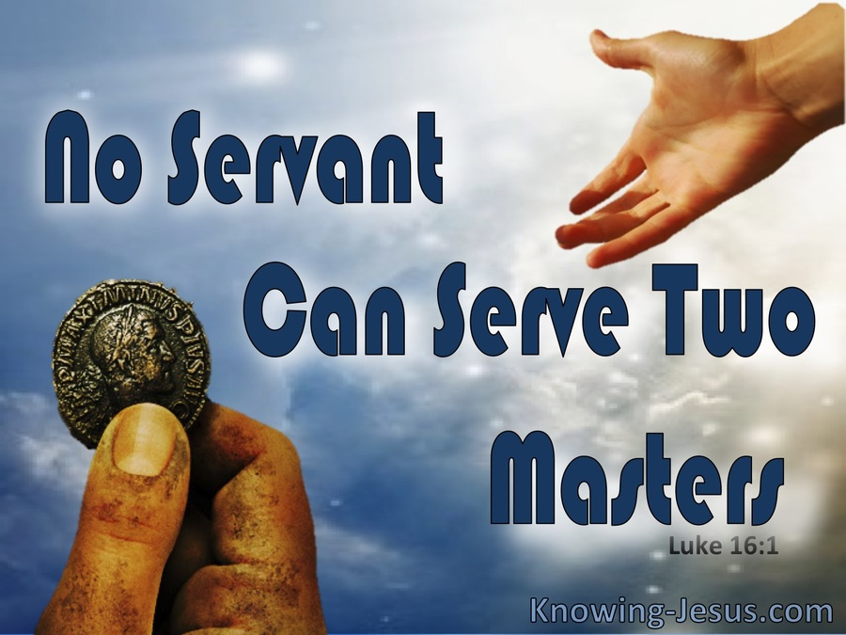

Celebrant: The Rev’d John Marshall
Intercessor and Eucharistic Minister: Alan Dewart
Eucharistic Minister: Misty Burney
Lectors: Misty Burney and Bill Nitterauer
Pentecost 15
September 21, 2025
Holy Eucharist Rite II

Prelude
"There Is a Balm in Gilead" (trad., arr. Adolphus Hailstork)
Entrance Hymn
Stand and sing Hymn 390 "Praise to the Lord, the Almighty, the King of creation"

Blessed be God: Father, Son, and Holy Spirit
And blessed be his kingdom, now and for ever. Amen.

Opening Song of Praise S 280 Glory to God (Canticle 20) (Powell)

Celebrant | The Lord be with you.
People | And also with you.
Celebrant | Let us pray.
O God, because without you we are not able to please you mercifully grant that your Holy Spirit may in all things direct and rule our hearts; through Jesus Christ our Lord, who lives and reigns with you and the Holy Spirit, one God, now and for ever. Amen.
The Lessons
A Reading from the book of the prophet Amos

Amos 8:4-7
Hear this, you that trample on the needy,
and bring to ruin the poor of the land,
saying, "When will the new moon be over
so that we may sell grain;
and the sabbath,
so that we may offer wheat for sale?
We will make the ephah small and the shekel great,
and practice deceit with false balances,
buying the poor for silver
and the needy for a pair of sandals,
and selling the sweepings of the wheat."
The Lord has sworn by the pride of Jacob:
Surely I will never forget any of their deeds.

The Word of the Lord.
Thanks be to God.

PSALM 113
The choir will chant the verses in plain type. The congregation is invited to chant the verses in bold type, and to sing the antiphon.

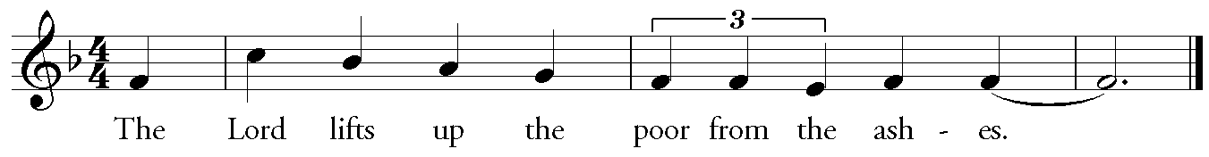
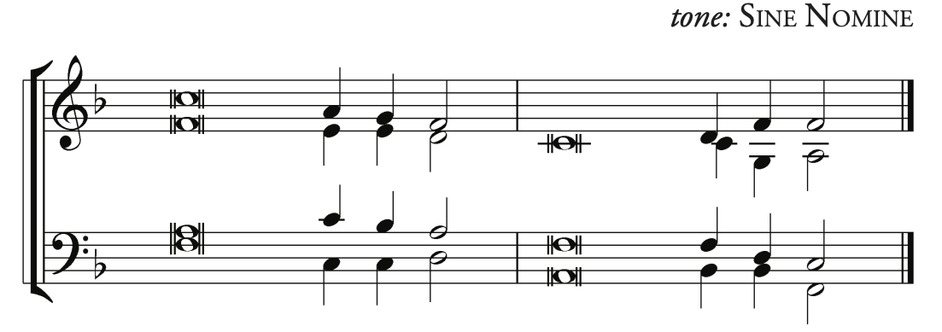
1 Hallelujah! … Give praise you servants [of] the Lord;*
praise the [name of] the Lord.
2 Let the name of the [Lord] be blest,*
from this time forth for-[ev]-ermore.
3 From the rising of the sun to its [go]-ing down*
let the name of the [Lord] be praised.
4 The Lord is high a-[bove] all nations,*
and his glory a-[bove] the heavens.
Antiphon
5 Who is like the Lord our God, … who sits en-[throned] on high,*
but stoops to behold the heavens [and] the earth?
6 He takes up the weak [out of] the dust*
and lifts up the [poor from] the ashes.
7 He sets them [with] the princes,*
with the princes [of] his people.
8 He makes the woman of a [child]-less house*
to be a joyful [mother] of children.
Antiphon
A Reading from Paul's First letter to Timothy.

1 Timothy 2:1-7
First of all, I urge that supplications, prayers, intercessions, and thanksgivings be made for everyone, for kings and all who are in high positions, so that we may lead a quiet and peaceable life in all godliness and dignity. This is right and is acceptable in the sight of God our Savior, who desires everyone to be saved and to come to the knowledge of the truth. For
there is one God;
there is also one mediator between God and humankind,
Christ Jesus, himself human,
who gave himself a ransom for all
-- this was attested at the right time. For this I was appointed a herald and an apostle (I am telling the truth, I am not lying), a teacher of the Gentiles in faith and truth.
The Word of the Lord.
Thanks be to God.
Sequence Hymn
Stand and sing Hymn 601 "O day of God, draw nigh" (vv. 1-4)
The Holy Gospel according to Luke
Glory to you, Lord Christ.

Luke 16:1-13
Jesus said to the disciples, "There was a rich man who had a manager, and charges were brought to him that this man was squandering his property. So he summoned him and said to him, `What is this that I hear about you? Give me an accounting of your management, because you cannot be my manager any longer.' Then the manager said to himself, `What will I do, now that my master is taking the position away from me? I am not strong enough to dig, and I am ashamed to beg. I have decided what to do so that, when I am dismissed as manager, people may welcome me into their homes.' So, summoning his master's debtors one by one, he asked the first, `How much do you owe my master?' He answered, `A hundred jugs of olive oil.' He said to him, `Take your bill, sit down quickly, and make it fifty.' Then he asked another, `And how much do you owe?' He replied, `A hundred containers of wheat.' He said to him, `Take your bill and make it eighty.' And his master commended the dishonest manager because he had acted shrewdly; for the children of this age are more shrewd in dealing with their own generation than are the children of light. And I tell you, make friends for yourselves by means of dishonest wealth so that when it is gone, they may welcome you into the eternal homes.
"Whoever is faithful in a very little is faithful also in much; and whoever is dishonest in a very little is dishonest also in much. If then you have not been faithful with the dishonest wealth, who will entrust to you the true riches? And if you have not been faithful with what belongs to another, who will give you what is your own? No slave can serve two masters; for a slave will either hate the one and love the other, or be devoted to the one and despise the other. You cannot serve God and wealth."
The Gospel of the Lord.
Praise to you, Lord Christ.

Sequence Hymn (continued)
Hymn 601 "O day of God, draw nigh" (v. 5)
Sit for The Homily The Rev’d John Marshall
Stand for The Nicene Creed (BCP p. 358)

We believe in one God, the Father, the Almighty, maker of heaven and earth, of all that is, seen and unseen.
We believe in one Lord, Jesus Christ, the only Son of God, eternally begotten of the Father, God from God, Light from Light, true God from true God, begotten, not made, of one Being with the Father. Through him all things were made. For us and for our salvation he came down from heaven: by the power of the Holy Spirit he became incarnate from the Virgin Mary, and was made man. For our sake he was crucified under Pontius Pilate; he suffered death and was buried. On the third day he rose again in accordance with the Scriptures; he ascended into heaven and is seated at the right hand of the Father. He will come again in glory to judge the living and the dead, and his kingdom will have no end.
We believe in the Holy Spirit, the Lord, the giver of life, who proceeds from the Father and the Son. With the Father and the Son he is worshiped and glorified. He has spoken through the Prophets.
We believe in one holy catholic and apostolic Church. We acknowledge one baptism for the forgiveness of sins. We look for the resurrection of the dead, and the life of the world to come. Amen.

Kneel as you are able for the
Prayers of the People

God is just, God is one. But we are often fragmented and confused by many wants. Let us gather our needs now and offer them confidently and simply to God, our Father, saying: Lord, hear our prayer.

For the leaders of the world powers, that they be just and honorable in their dealings with one another, we pray to the Lord.
Lord, hear our prayer

For peace, a reduction of arms, and an end to war and terrorism, we pray to the Lord.
Lord, hear our prayer

That the church and its leaders may be ingenious and tireless in preaching the good news, we pray to the Lord.
Lord, hear our prayer

That all Christians may hold their goods and money lightly and use them for the sake of God’s dominion, we pray to the Lord.
Lord, hear our prayer

That all elected officials may respond to the needs of their community and serve the common good, we pray to the Lord.
Lord, hear our prayer.

For the sick, the aged, the lonely, especially Heidi, Joanne, Paul, Mike, Colleen, Robin, Cathy, Bethany, Heather, Jim, Rosie, Anthony, Baby Theodore, Steve, Jeanette, Margaret, Thomas, Gabriel, Karen, Natalie, Darlene, Larry, Tony, Don, Baby Sofia, Cheryl, Paula, Sheila, Sue, Joe, Mike, Sarah, and any who cannot be with us today, that they know our kindness and God’s mercy, we pray to the Lord.
Lord, hear our prayer

That the wealthy and those with no material want may use their bounty in keeping with their calling, we pray to the Lord.
Lord, hear our prayer

We pray for:
Anglican Communion – The Province of the Episcopal Church of South Sudan
In the Diocese – St. Martin-in-the-Fields, Grand Island and Trinity, Hamburg
Just God, one God, we live in this world and look for the world to come. Teach us what to ask for: give us all we need. Make us life-givers with you who build your dominion here, in the name of Jesus the Lord.
Let us confess our sins against God and our neighbor.
Most merciful God,
we confess that we have sinned against you
in thought, word, and deed,
by what we have done,
and by what we have left undone.
We have not loved you with our whole heart;
we have not loved our neighbors as ourselves.
We are truly sorry and we humbly repent.
For the sake of your Son Jesus Christ,
have mercy on us and forgive us;
that we may delight in your will,
and walk in your ways,
to the glory of your Name. Amen.
Almighty God have mercy on you, forgive you all your sins through our Lord Jesus Christ, strengthen you in all goodness, and by the power of the Holy Spirit keep you in eternal life. Amen.
Celebrant The peace of the Lord be always with you.
People And also with you.

Offertory ANTHEM
"Be Thou My Vision" (text: Eleanor H. Hull; music: trad., arr. Richard Shepherd)

DOXOLOGY
Great God, our gratitude we bring,
Accept our humble offering: Alleluia, alleluia!
For all the gifts on us bestowed,
Thy name be evermore adored.
Alleluia, alleluia! Alleluia, alleluia, alleluia!
(Text: Josephine Heard/Tune: Laßt uns erfreuen)
The Holy Communion

Celebrant | The Lord be with you.
People | And also with you.
Celebrant | Lift up your hearts.
People | We lift them to the Lord.
Celebrant | Let us give thanks to the Lord our God.
People | It is right to give him thanks and praise.
God of all power, Ruler of the Universe, you are worthy of glory and praise.

Glory to you for ever and ever.
At your command all things came to be: the vast expanse of interstellar space, galaxies, suns, the planets in their courses, and this fragile earth, our island home.
By your will they were created and have their being.
From the primal elements you brought forth the human race, and blessed us with memory, reason, and skill. You made us the rulers of creation. But we turned against you, and betrayed your trust; and we turned against one another.
Have mercy, Lord, for we are sinners in your sight.
Again and again, you called us to return. Through prophets and sages you revealed your righteous Law. And in the fullness of time you sent your only Son, born of a woman, to fulfill your Law, to open for us the way of freedom and peace.
By his blood, he reconciled us.
By his wounds, we are healed.
And therefore we praise you, joining with the heavenly chorus, with prophets, apostles, and martyrs, and with all those in every generation who have looked to you in hope, to proclaim with them your glory, in their unending hymn:

Sanctus WLP 858 (green hymnal) Holy, holy, holy (American folk melody, harm. Pruner)
Holy, holy, holy Lord, God of power and might,
heaven and earth are full of your glory.
Hosanna in the highest.
Blessed is the one who comes in the name of the Lord.
Hosanna in the highest.
And so, Father, we who have been redeemed by him, and made a new people by water and the Spirit, now bring before you these gifts. Sanctify them by your Holy Spirit to be the Body and Blood of Jesus Christ our Lord.
On the night he was betrayed he took bread, said the blessing, broke the bread, and gave it to his friends, and said, “Take, eat: This is my Body, which is given for you. Do this for the remembrance of me.”
After supper, he took the cup of wine, gave thanks, and said, “Drink this, all of you: This is my Blood of the new Covenant, which is shed for you and for many for the forgiveness of sins. Whenever you drink it, do this for the remembrance of me.”
Remembering now his work of redemption, and offering to you this sacrifice of thanksgiving,
We celebrate his death and resurrection,
as we await the day of his coming.

Lord God of our Fathers; God of Abraham, Isaac, and Jacob; God and Father of our Lord Jesus Christ: Open our eyes to see your hand at work in the world about us. Deliver us from the presumption of coming to this Table for solace only, and not for strength; for pardon only, and not for renewal. Let the grace of this Holy Communion make us one body, one spirit in Christ, that we may worthily serve the world in his name.
Risen Lord, be known to us in the breaking of the Bread.
Accept these prayers and praises, Father, through Jesus Christ our great High Priest, to whom, with you and the Holy Spirit, your Church gives honor, glory, and worship, from generation to generation. AMEN.
And now, as our Savior Christ has taught us, we are bold to say,

Our Father, who art in heaven,
hallowed be thy Name,
thy kingdom come,
thy will be done, on earth as it is in heaven.
Give us this day our daily bread.
And forgive us our trespasses,
as we forgive those who trespass against us.
And lead us not into temptation,
but deliver us from evil.
For thine is the kingdom,
and the power, and the glory,
forever and ever. Amen.

Fraction Anthem WLP (green hymnal) 875 Be known to us (James)
Refrain (choir only, then all):
Be known to us, Lord Jesus, in the breaking of the bread.
The bread which we break, alleluia,
Is the communion of the body of Christ. (Refrain)
One body are we, alleluia,
For though many we share one bread.(Refrain)
Communion HymnS
Hymn 701 "Jesus, all my gladness"
LEVAS 203 "There is a Balm in Gilead"
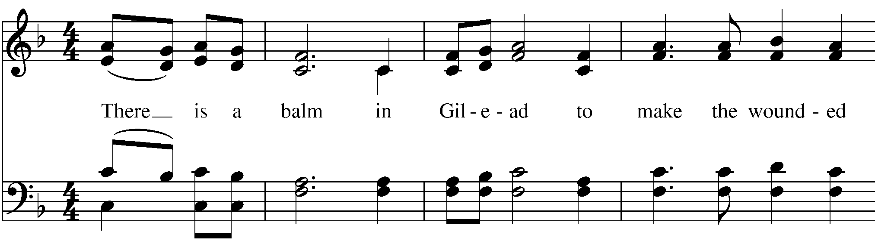

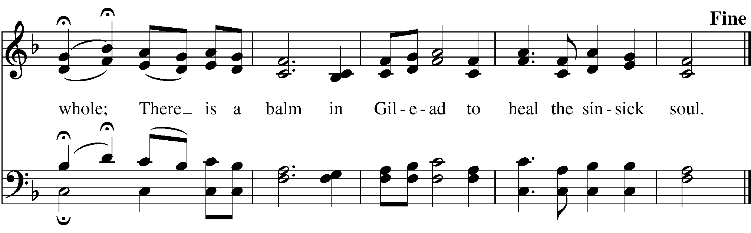
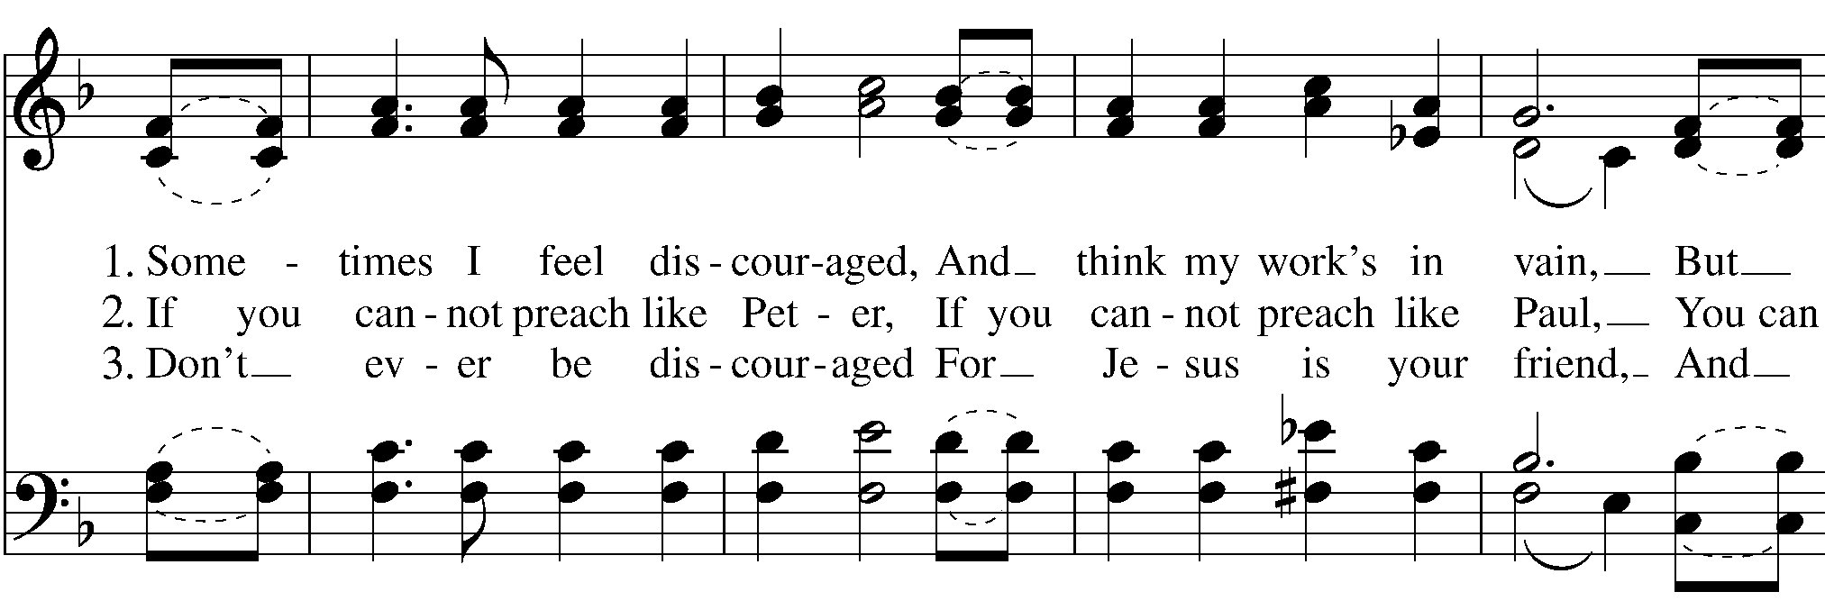
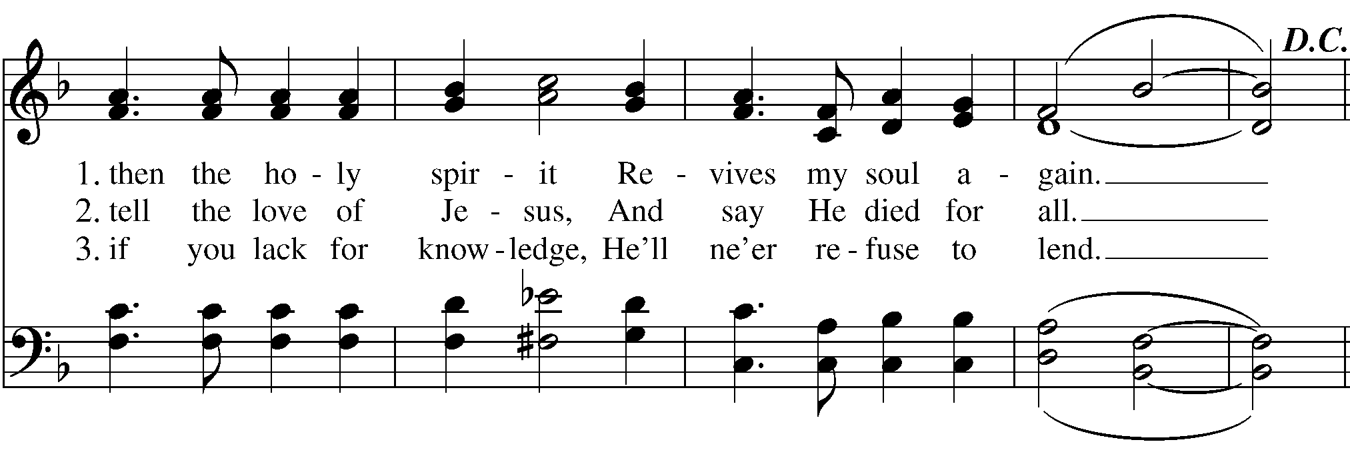The Prayer after Communion

Let us pray

Eternal God,
you have graciously accepted us as living members
of our Savior Jesus Christ,
and you have fed us with spiritual food
in the Sacrament of his Body and Blood.
Send us now into the world in peace,
and grant us strength and courage
to love and serve you
with gladness and singleness of heart;
through Christ our Savior. Amen.

Blessing
The blessing, mercy, and grace of God Almighty, the Father, the Son, and the Holy Spirit, be upon you, and remain with you for ever. Amen.

Post-Communion Hymn
Stand and sing Hymn 583 “O holy city, seen of John"

Dismissal
 | Let us go forth in the name of Christ..
People | Thanks be to God.

Postlude
“Joy” (John Coltrane)


St. Mark's Prayer Roll

We pray for:
Anglican Communion – The Province of the Episcopal Church of South Sudan
In the Diocese – St. Martin-in-the-Fields, Grand Island and Trinity, Hamburg

Those in need or trouble –Heidi, Joanne, Paul, Mike, Colleen, Robin, Cathy, Bethany, Heather, Jim, Rosie, Anthony, Baby Theodore, Steve, Jeanette, Margaret, Thomas, Gabriel, Karen, Natalie, Darlene, Larry, Tony, Don, Baby Sofia, Cheryl, Paula, Sheila, Sue, Joe, Mike, Sarah

This Week at St. Mark’s
Sunday 09/21
8:00am Eucharist Rite I
9:45am Sunday School K – Grade 5
10:00am Eucharist Rite II
11:00am Coffee Hour
3:00pm Concert
Wednesday 09/24
10:00am Eucharist Rite I
11:00am Book Club
Thursday 09/25
7:00pm Choir Rehearsal
Saturday 09/27
6:00pm Open AA Meeting
Sunday 09/28
8:00am Eucharist Rite I
9:45am Sunday School K – Grade 5
10:00am Eucharist Rite II
11:00am Coffee Hour
3:00pm Concert

ST. MARK'S CONCERT SERIES
TODAY, Sunday, September 21, 3PM: Joe Bellanti, singer/songwriter & pianist
JOE BELLANTI is a Buffalo-based piano player and singer/songwriter. He has been part of the Buffalo music scene since his college days in the early 1980s, playing with several local and touring bands, and he continues exploring new territory today, playing solo shows and jamming with established groups as opportunities arise. From the sound of the music to a proven ability to connect with an audience, Joe has been equally comfortable as a headliner or in support of other musicians, always with an ear toward making the overall experience a positive one for the audience. $20 suggested donation (to support this and future concerts at St. Mark's)
Sunday, October 19, 3pm: Kindred, Celtic music performed by David and Felicia Meyer
Stay tuned for more concerts in 2026!

OKTOBERFEST 2025
SATURDAY, SEPTEMBER 27, 2025!
At the OP Train Depot 6-10pm
FEATURING AUTHENTIC
- German beers- First Line Brewing and Wayland Brewing Company
- German music- The Frankfurter Band
- German foods- Dinner catered by St. Mark’s Church
- Along with Food trucks, Entertainment, Games and more…
This year there are three ways in which you can support this St. Mark’s fund raiser with the purchase of tickets for the event or a donation.
- Buy or sell your paper tickets- send/take your check or cash along with the completed ticket stub(s) to the church office
- Use the QR code in the church letter you received- complete the form. You will be taken to the St. Mark’s electronic giving website (tithely.com). Choose Oktoberfest and pay for your tickets with a credit card. A receipt will be sent to your email – that becomes your ticket. Take that with you to the event.
- Pay cash or use a credit card at the event. No reserved meals.
PRESALE TICKETS WILL BE OFFERED UNTIL MIDNIGHT SEPT. 24. DINNERS WILL BE RESERVED FOR PICK-UP UNTIL 7PM THE NIGHT OF THE EVENT- AFTER 7PM, NO GUARANTEES
(There is a fee for the use of a credit card. We ask that you kindly choose to cover that fee with your ticket payment as a goodwill donation to St. Mark’s.)
Mark your calendars for this exciting event! Break out your Lederhosen and Dirndls! This event promises to be “Wunderbar!”

COFFEE HOUR
Coffee hour will resume this Sunday, September 21. Please join us in the Morrow Room after 10 o’clock service for coffee, sweets and fellowship.
Fall is a very busy time for all, but we could use your help to host a coffee hour. Please sign up to host on the Coffee Hour sign- up sheet posted at the church side door entrance.

